SYSEN 5381 Tool V1: “News for People in a Hurry”

Project Manager: Janhavi Satyawan Gaikwad
Backend Developer: Anurag Yadav
Frontend Developer: William Manno, Puchun Niu
DevOps Engineer: Tony Klar

GitHub: https://github.com/janhaviprof-bot/DS-AIforSystemsEng-Project/tree/main/AppV1
Website via Digital Ocean: https://sea-turtle-app-4oc2t.ondigitalocean.app/

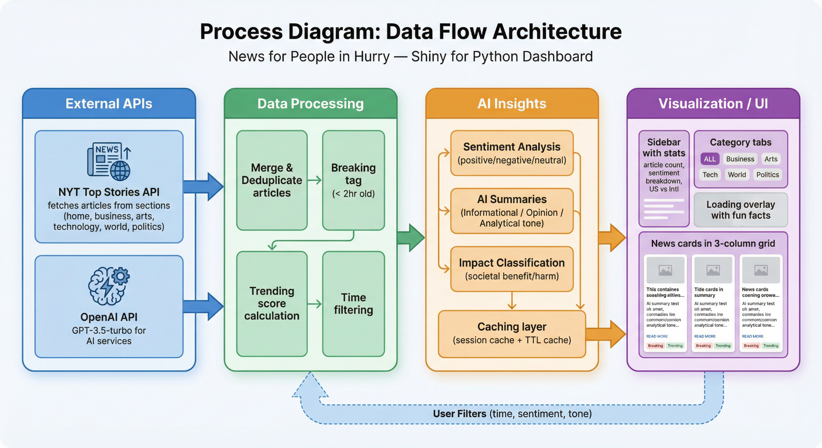

The application is called "News for People in a Hurry" and is a Shiny web application implemented in Python. The application retrieves the top articles from the New York Times. The application initializes the data by sending parallel HTTP GET requests via the httpx library to the New York Times Top Stories API at /svc/topstories/v2/{section}.json for six sections defined in the config.NYT_SECTIONS list. The results are parsed into Pandas data frames, concatenated, and deduplicated by the column 'url.' The results are stored in the reactive.value object called enriched_articles_state, which is the source for all subsequent computations. The object n_sections is kept during the merge operation because it is useful for scoring. If the New York Times API key is not present, the object is just initialized as an empty data frame.

Three operations are applied to modules/categorization.py at the same time to extend the DataFrame: add_breaking_tag() compares each article's published_date to a two-hour UTC threshold to generate a boolean is_breaking column; compute_trending_score() computes a weighted aggregate of topic richness (len(des_facet) * 0.4), editorial activity ((updated_date - published_date) * 0.3), media presence (bool(multimedia) * 0.2), and cross-section relevance ((n_sections > 1) * 0.1), which flags articles scoring above 0.5 as is_trending; and sort_latest() sorts by published_date in descending order. The card selection algorithm implemented in select_first_six() is a deterministic selection of page-one articles: indices 0-1 are selected from the breaking articles pool, 2-3 from the trending articles excluding those with already-used URLs, and 4-5 from the latest articles excluding all prior articles. select_next_six() is then used to paginate articles by taking a list of used URLs as input and returning the next six articles based on the latest ordering, utilizing a reactive.value(dict()) to reset based on changes to input.time_hours or input.sentiment.

Three GPT-3.5-turbo integrations are used in the modules/ai_services.py and modules/impact_classifier.py files, which all utilize httpx.Client. Sentiments utilize a ThreadPoolExecutor with 3 worker threads for up to 10 headlines per API request. _parse_sentiment_response() processes the response, splitting on whitespace and commas, then checks for positive, negative, neutral, and pads with "neutral" if the model returns fewer labels than expected, with the results stored in a session-scoped sentiment_cache dictionary with the URL as the key. The summary generation accepts a title, abstract, and subtitle tuple along with the user-selected tone, generating a tone-specific system prompt and caching the results in the summary_cache dictionary with the key {url}|{tone}. The UI resolves the entire chain via the make_cards_ui(category) function, which filters the enriched articles via filter_by_time(), sentiment, then filter_by_category() before selecting the cards, then fetching the uncached summaries and rendering the news_card_ui() components inside a div with the class "news-cards-grid."

